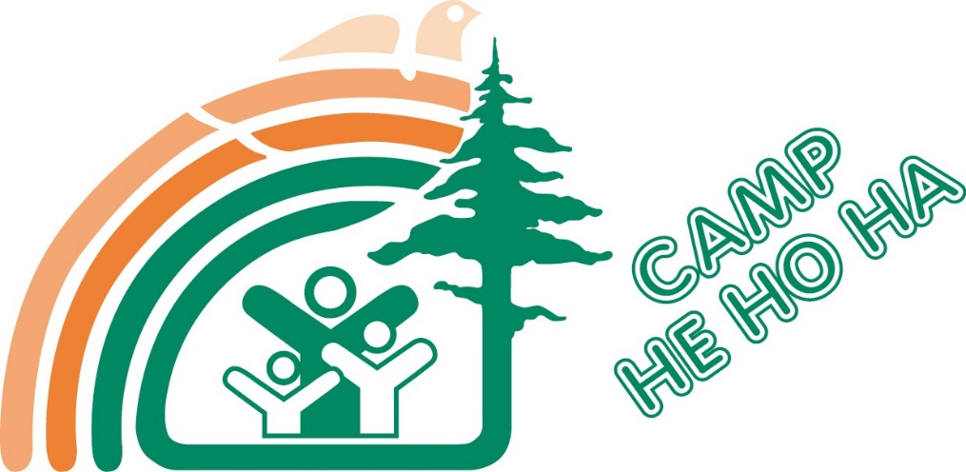
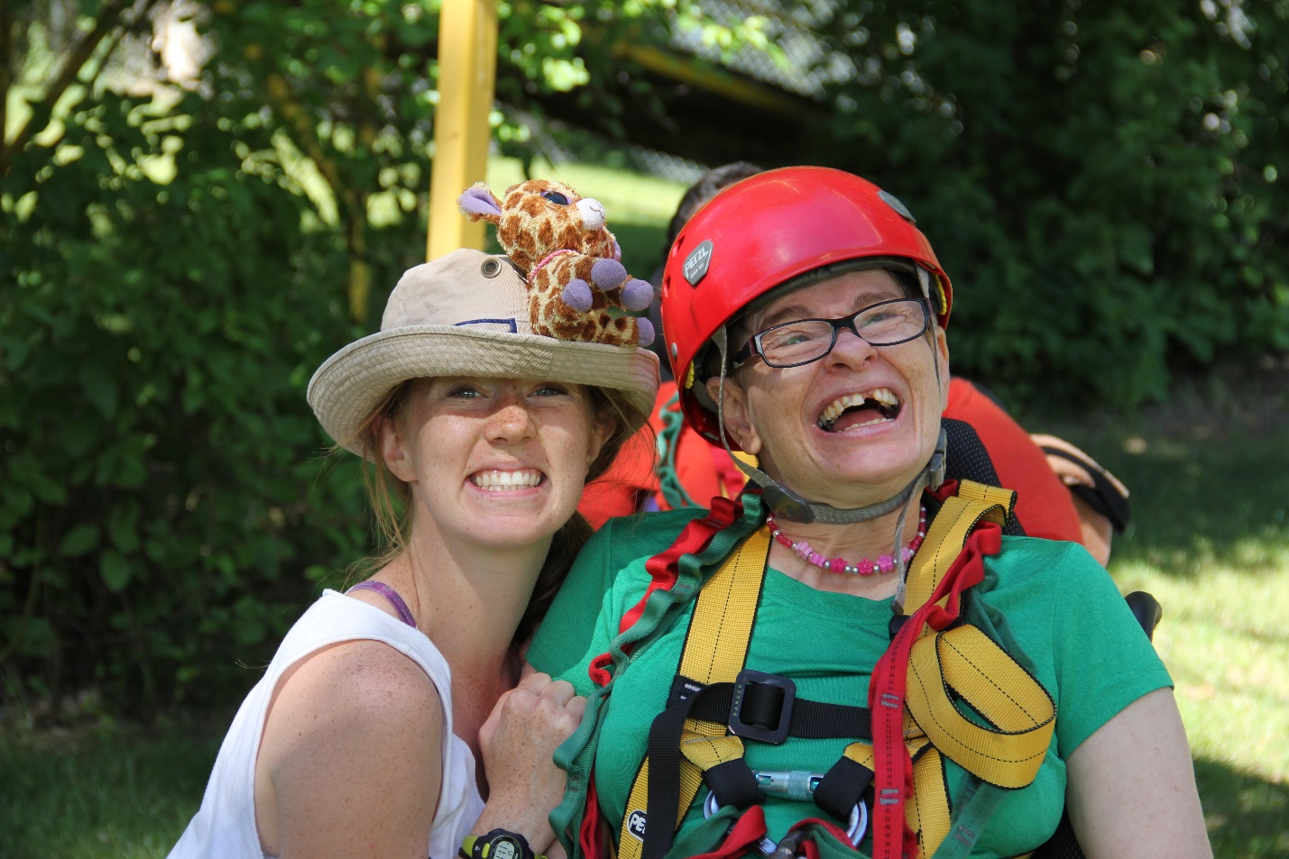Making a Difference
in the Lives of Special People
Camp Health, Hope and Happiness is dedicated to providing a safe, rewarding environment for people with disabilities to explore their full potential and encourage independence.
Many of our kind supporters from the past are now facing attrition. As we all know, there are very few new members joining service clubs such as the Elks, or the Lions Clubs. These are groups that have been incredibly generous to us but now we have recognized our need to seek financial support elsewhere. Of the 47% of the funding considered “donations”, 38% is from these community service groups.
A steadily declining source of income threatens the existence of Camp He Ho Ha. With our increasing costs of operation, and also our need to upgrade and improve our aging facility, we are in need of new supporters more than ever.
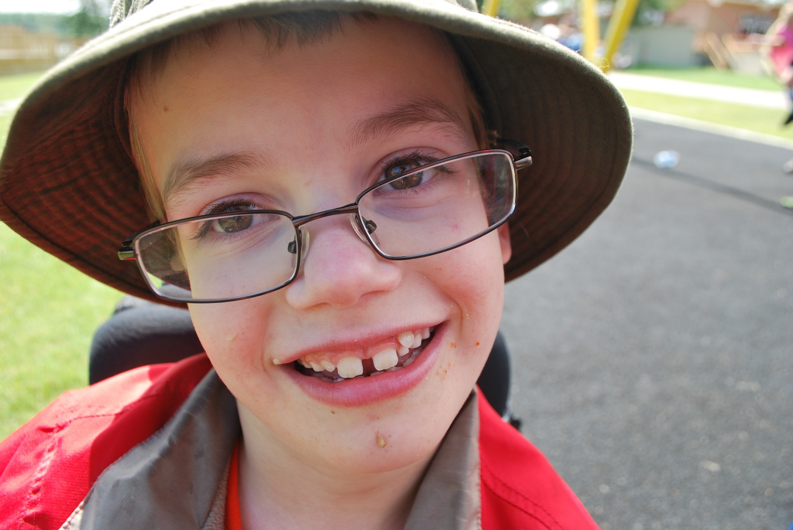
Looming Financial Death

Why would a foundation that is struggling to maintain its program use so much of its financial support to subsidize the campers that attend?

Each year, approximately 750 campers attend our summer programs. With camp fees only being equivalent to 45% of the cost of caring for the camper for the week of their attendance, the remaining 55% is subsidized by Camp He Ho Ha.
Camp fees cannot be increased to eliminate this expense to Camp He Ho Ha when the population of attendees is so vulnerable.
Provincial government support for individuals with disabilities is limited; a maximum of $1588.00 per month is available. This money is very often the only financial support that these individuals have available and therefore must be used for rent, food, clothing, and all other living expenses. It is not feasible for these individuals to budget more for recreation.

Backwards Business Model

and Forward
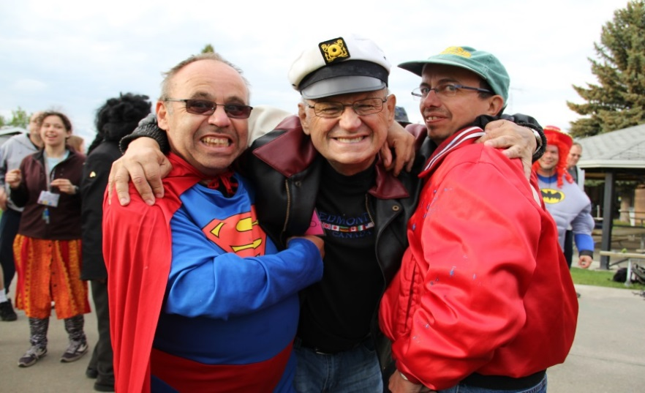
2 Year Financial Requirements

Facility Furniture | $110,000
Golf Carts | $12,000
Trail and Road Paving | $375,000
8 Wheel Chairs | $8,000
3 of 5 sections of Sidewalk | $180,000
Lawn Tractor | $15,000

5 Year Financial Requirements

Maintenance Utility Vehicle | $30,000
Outboard Motors for Barges | $25,000
Office Flooring | $15,000
Staff Bungalow | $420,000
Staff Duplex | $356,000
Maintenance Tractor | $70,000

2015
The proposed operational budget for 2015 is 2.4 million dollars. Traditionally 47% of our funding comes from donations. This equates to 1.1 million dollars we are seeking every year to maintain the programs and ability to subsidize the 750 campers ($540,000) we currently serve.
We are currently struggling to raise these funds to complete this requirement for our 2015 budget. In addition to raising funds to cover these operating expenses there are some other capital project expenses that need to be completed consisting of the following items:

Sidewalk Replacement:
$54,259
Swimming Pool Deck:
$68,000
Pool Shower Room Flooring:
$56,870
Medical Centre Flooring:
$14,571
12 Commodes
$15,000

7 Year Future Goal…24 Room – 3 Storey Apartment Complex Complete with Staff Lounge + Dining Hall Expansion
$7 Million Dollars
Summer camps have been operating at full capacity for many years. 29% of camps funding comes from rental revenue. These additional accommodations would enable us to expand our summer program by 160 individuals annually resulting in increased rental revenues and greater self sufficiency over the long term while meeting a greater demand.

Can we count on your support for our future?
We Care (up to $5,000)
Welcome to Camp Health, Hope and Happiness. Every dollar that is donated helps us to provide a life changing experience for people with special needs. Our campers thank you. If you have given $2,500 or more, your name will be listed on our wesbite as a contributer to camp. Your generosity is appreciated.

7 Smiles ($5,001-$9,999)
Your donation of $5,000 has given 7 campers the gift of summer camp at Camp He Ho Ha. Seven people with disabilities will now have a summer to cherish for years to come; for that we would like to place your name on a bronze leaf on the “Tree of Hope” for the next 3 years. Also, we would like to invite you to join us at camp for a day of appreciation. And of course, your name will be displayed as a contributer to camp on our website and also in our newsletter.

We Make a Difference ($10,000-$24,999)
With your substantial gift of $10,000 14 campers will receive the experience of summer camp at Camp He Ho Ha. Fourteen people with disabilities will now have a summer to cherish for years to come; for that we would like to place your name on a Silver leaf on the “Tree of Hope” for the next 3 years, and display a cheque presentation photo on Camp He Ho Ha’s social media network. Also, we would like to invite you to join us at camp for a day of appreciation. And of course, your name and logo (if applicable) will be displayed as a contributer to camp on our website and also in our annual newsletter. Your financial gerousity would be making huge difference in these campers lives.

Big Dreams ($25,000 or greater one time donation)
A “Big Dreams” donation of $25,000 would enable 40 campers to experience one week of camp at Camp He Ho Ha. These individuals with disabilities will now have a summer of memories for many years to come; in recognition of this we will place your name on a Gold leaf on the “Tree of Hope” for the next 3 years. Also, you will be co-sponsoring one of our ten summer camps which includes recognition for that week of camp. In addition to this you would be invited to join us at camp for a day of appreciation. There would be a cheque presentation picture displayed on all of our social media platforms. Finally, your name and logo (if applicable) will be displayed as a contributor to camp on our website and also in our annual newsletter. This is an incredible opportunity to make a difference in 40 individuals with special needs lives. With this much help, we can start dreaming about making camp bigger and better.

Building Our Future ($25,000 or greater partnership)
Your partnership with Camp Health, Hope and Happiness is creating the sustainabiltiy that is crucial to our organization. Together we are changing the lives of people of disabilities, granting smiles and warming hearts. We know, that by your generosity at this level, you recognize the importance of spreading happiness and love in the world. We want you to be recognized for this. We will add a golden leaf to our “Tree of Hope” which will remain on the tree for term of 3 years from the last year of your donation. You will be co-sponsoring one of our ten summer camps which includes recognition for that week of camp. In addition to this, you would be invited to join us at your camp for a day to see how you have made a difference. Your name (and logo if applicable), as well as a picture of a cheque presentation will be posted on our website and on our social media pages. We would like to commemorate you on our social media pages and within our annual newsletter with a social story too; tell the story of your business or family and how you have made a difference for our campers. In honour of your annual donation for an agreed term of 2 or more years, we will give to you a plaque for display in your location of choice, whether it be in your business or in your home. We look forward to sharing this journey into the future.

Leaf a Legacy ($50,000)
This monumental donation deserves a lifetime of recognition. A platinum leaf will be added to our “Tree of Hope” indefinitely. How wonderful do you feel for adding happiness and unconditional love to the life of 80 incredible people? Your $50,000 will forever change their lives. We would love to have your presence at your camp for a day for you to see what camp brings to our campers, and to see what a difference you have made. Come to camp for a day so that we can show you the appreciation you deserve. For $50,000 you would be a sponsor of one of our 10 summer camps of your choice. Your name and a business card sized logo that links to your website(if applicable), and also a cheque presentation photo, will be posted on our website as well as on our social media platforms. We would like to tell the story of your business or family to all of the supporters of Camp Health, Hope and Happiness. An entire article dedicated to who you are and how you make a difference will also be added to our annual newsletter. And finally, we will give you a plaque recognizing your donation to take home or to take to your business where you can showcase with pride how you have left a legacy and Camp He Ho Ha.

We Thank You

