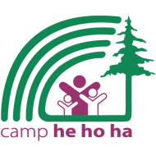
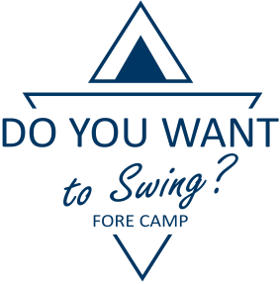
Swing Fore Camp 2022
Charity Golf Tournament in support of Camp He Ho Ha
Friday, August 12, 2022 | Pineridge Golf Resort

Sponsorship Benefits Overview
Benefits | Dinner $7,500 | Cart  $5,000 | Platinum $3,000 plus an auction item or team prize | Gold $2,000 plus an auction item or team prize | Wine  $1,500 | Silver $1,000 plus an auction item or team prize | Lunch  $750 | Hole-in-one $500 plus the cost of insurance | Bronze $500 plus an auction item or team prize
First right of refusal for 2023 Tournament | √ | √
One complimentary bottle of wine with dinner | √ | √
Company logo promoted at golfer registration | √ | √ | √
Priority seating and serving at banquet | First Served | √ | √
Social Media write-up and links to your website (write-up provided by sponsor) | √ | √ | √
Presentation of a plaque recognizing your support | √ | √ | √ | √
Table for Company representative(s) at hole | √ | √ | √ | √ |  |  | At Lunch Location
Opportunity to include promotional material | On tables | On all carts | In gift bags | In gift bags | In gift bags | In gift bags | At lunch location | At hole-in-one hole | In gift bags
Green fees with power cart at Pineridge Golf Resort for 4 people ($200 value/person) | 4 individuals | 4 individuals | 4 individuals | 2 individuals | 1 individual | 1 individual
Company logo signage | On banquet & buffet tables | On all carts | On the course | On the course | On wine raffle table & at bar | On the course | At lunch location | On the course
Social media acknowledgement | √ | √ | √ | √ | √ | √ | √ | √ | √
Thanked in Camp He Ho Ha electronic newsletter | Logo, name, & Website link | Logo, name, & Website link | Logo, name, & Website link | Logo and name only | Logo and name only | Logo and name only | Logo and name only | Name only | Name only
Acknowledgement at banquet | √ | √ | √ | √ | √ | √ | √ | √ | √

Updated February 9, 2022

